CSC500 Module 6: Portfolio Milestone

Online Shopping Cart

Source Code
""""
Milestone 2
Online Shopping Cart
Author: Shadab
"""
# Python code to calculate the total cost of all items and description of items in the Shopping Cart
# user provides Inputs at Runtime and also validations for inputs
from datetime import datetime
# ----------Item Class---------- #
class ItemToPurchase:
# Constructor to Initialize Item Details
def __init__(self, name = "none", price = 0.0, quantity = 0, description = "none"):
self.itemName = name
self.itemPrice = price
self.itemQuantity = quantity
self.itemDescription = description
# Method to Calculate and Display the Total Cost of the Item
def print_item_cost(self):
total_item_cost = self.itemPrice * self.itemQuantity
print(f"\n{self.itemName} {self.itemQuantity} @ ${self.itemPrice} = ${total_item_cost}")
# Function to Validate the Purchased Item Name
def get_valid_item_name(duplicate_items):
while True:
item_name = input("Enter Purchased Item Name: \n").strip()
# Validation of Empty Input
if item_name == "":
print("Item Name cannot be Blank!! Please Enter Purchased Item Name.\n")
# Validation to prevent item names with only Numericals
elif item_name.isnumeric():
print("Warning!! Item Name cannot contains only Numerical Characters.\n")
# Validation to check for Special Characters
elif not item_name.replace(" ", "").isalnum():
print("Warning!! Item Name cannot contains Special Characters.\n")
# Validation to check if the Item Name already Exists
elif item_name.lower() in duplicate_items:
print("Warning!! Item name already exists.\n")
else:
duplicate_items.add(item_name.lower())
return item_name
# Function to Validate the Purchased Item Quantity
def get_valid_item_quantity():
while True:
item_quantity = input("Enter Purchased Item Quantity: \n").strip()
# Validation of Empty Input
if item_quantity == "":
print("Item Quantity cannot be Blank!! Please Enter Purchased Item Quantity.\n")
continue
try:
# Converting Quantity to Integer
quantity = int(item_quantity)
# Validation to check if Quantity is Negative or Zero
if quantity <= 0:
print("Warning!! Purchased Item Quantity should be greater than 0.\n")
# Validation to limit Quantity
elif quantity > 10000:
print("Warning!! Purchased Item Quantity is too high.\n")
else:
return quantity
except ValueError:
print("Warning!! Purchased Item Quantity must be an integer.\n")
# Function to Validate the Purchased Item Price
def get_valid_item_price():
while True:
item_price = input("Enter Purchased Item Price: \n").strip()
# Validation of Empty Input
if item_price == "":
print("Item Price cannot be Blank!! Please Enter Purchased Item Price.\n")
continue
try:
# Converting Price to Float
price = float(item_price)
# Validation to check if Price is Negative or Zero
if price <= 0:
print("Warning!! Purchased Item Price should be greater than 0.\n")
else:
return round(price, 2)
except ValueError:
print("Warning!! Purchased Item Price must be an integer.\n")
# Function to Get the Purchased Item Description
def get_valid_item_description():
item_description = input("Enter Purchased Item Description: \n").strip()
if len(item_description) > 100:
print("Warning!! Purchased Item Description is too long.\n")
return item_description[:100]
return item_description if item_description else "None"
# ----------Shopping Cart Class---------- #
class ShoppingCart:
def __init__(self, customer_name = "none", current_date = "January 1, 2020"):
self.customer_name = customer_name
self.current_date = current_date
self.cart_items = []
self.item_names = set()
# Add Item to Cart
def add_item(self, item):
self.cart_items.append(item)
self.item_names.add(item.itemName.lower())
# Remove Item from Cart
def remove_item(self, item_name):
if not self.cart_items:
print("Cart is empty. Nothing to remove.\n")
return
for item in self.cart_items:
if item.itemName.lower() == item_name.lower():
self.cart_items.remove(item)
self.item_names.discard(item.itemName.lower())
print("Item Removed Successfully, Removed Item " + item.itemName.lower())
return
print("Warning!! Item " + item.itemName + " is not found in the cart. Nothing was Removed\n")
# Modify Item Quantity
def modify_item(self, item_name):
if not self.cart_items:
print("Cart is empty. Nothing to modify.\n")
return
for item in self.cart_items:
if item.itemName.lower() == item_name.lower():
print("\nFor the Item " + item.itemName.lower() + "what needs to be modified:\n")
print("1. Quantity\n")
print("2. Price\n")
print("3. Description\n")
user_choice = input("Choose the option: \n").strip()
if user_choice == "1":
item.itemQuantity = get_valid_item_quantity()
elif user_choice == "2":
item.itemPrice = get_valid_item_price()
elif user_choice == "3":
item.itemDescription = get_valid_item_description()
else:
print("\nInvalid Choice!! Please Enter Valid Choice.\n")
print("\nItem Updated Successfully.\n")
return
print("\nItem not found in the cart. Nothing modified\n")
# Get Total Number of Items
def get_num_items_in_cart(self):
return sum(item.itemQuantity for item in self.cart_items)
# Get Total Cost
def get_cost_of_cart(self):
return sum(item.itemPrice * item.itemQuantity for item in self.cart_items)
# Print Total Cart Details
def print_total(self):
print("\n************ OUTPUT SHOPPING CART ************\n")
print(f"{self.customer_name}'s Shopping Cart - {self.current_date}\n")
print(f"Number of Items in Cart: {self.get_num_items_in_cart()}")
if not self.cart_items:
print("\nShopping Cart is Empty.\n")
else:
for item in self.cart_items:
item.print_item_cost()
print(f"\nTotal: ${self.get_cost_of_cart()}\n")
print('\n*************************************************\n')
# Print Item Descriptions
def print_descriptions(self):
print("\n************ OUTPUT ITEM'S DESCRIPTIONS ************\n")
print(f"{self.customer_name}'s Shopping Cart - {self.current_date}\n")
print("Shopping Cart Item Descriptions:\n")
if not self.cart_items:
print("\nShopping Cart is Empty.\n")
else:
for item in self.cart_items:
print(f"{item.itemName}: {item.itemDescription}")
print('\n***************************************************\n')
# ----------Shopping Cart Menu---------- #
def print_menu(cart):
while True:
print("\nMENU")
print("a - Add Item to Cart")
print("r - Remove Item from Cart")
print("c - Change Item Quantity")
print("i - Output Item's descriptions")
print("o - Output Shopping Cart")
print("q - Quit")
user_choice = input("\nChoose an option: \n").lower().strip()
if user_choice == "a":
name = get_valid_item_name(cart.item_names)
description = get_valid_item_description()
price = get_valid_item_price()
quantity = get_valid_item_quantity()
item = ItemToPurchase(name, price, quantity, description)
cart.add_item(item)
elif user_choice == "r":
name = input("Enter item name in the cart to remove: \n").strip()
cart.remove_item(name)
elif user_choice == "c":
name = input("Enter item name in the cart to modify: \n").strip()
cart.modify_item(name)
elif user_choice == "i":
cart.print_descriptions()
elif user_choice == "o":
cart.print_total()
elif user_choice == "q":
print("\nExited Cart")
break
else:
print("\nInvalid Choice!! Please Enter Valid Choice.\n")
# Main Function
def main():
name = input("Enter customer's name: \n")
date = datetime.now().strftime("%B %d, %Y")
print(f"\nCustomer Name: {name}")
print(f"Today's Date: {date}")
cart = ShoppingCart(name, date)
print_menu(cart)
if __name__ == "__main__":
main()
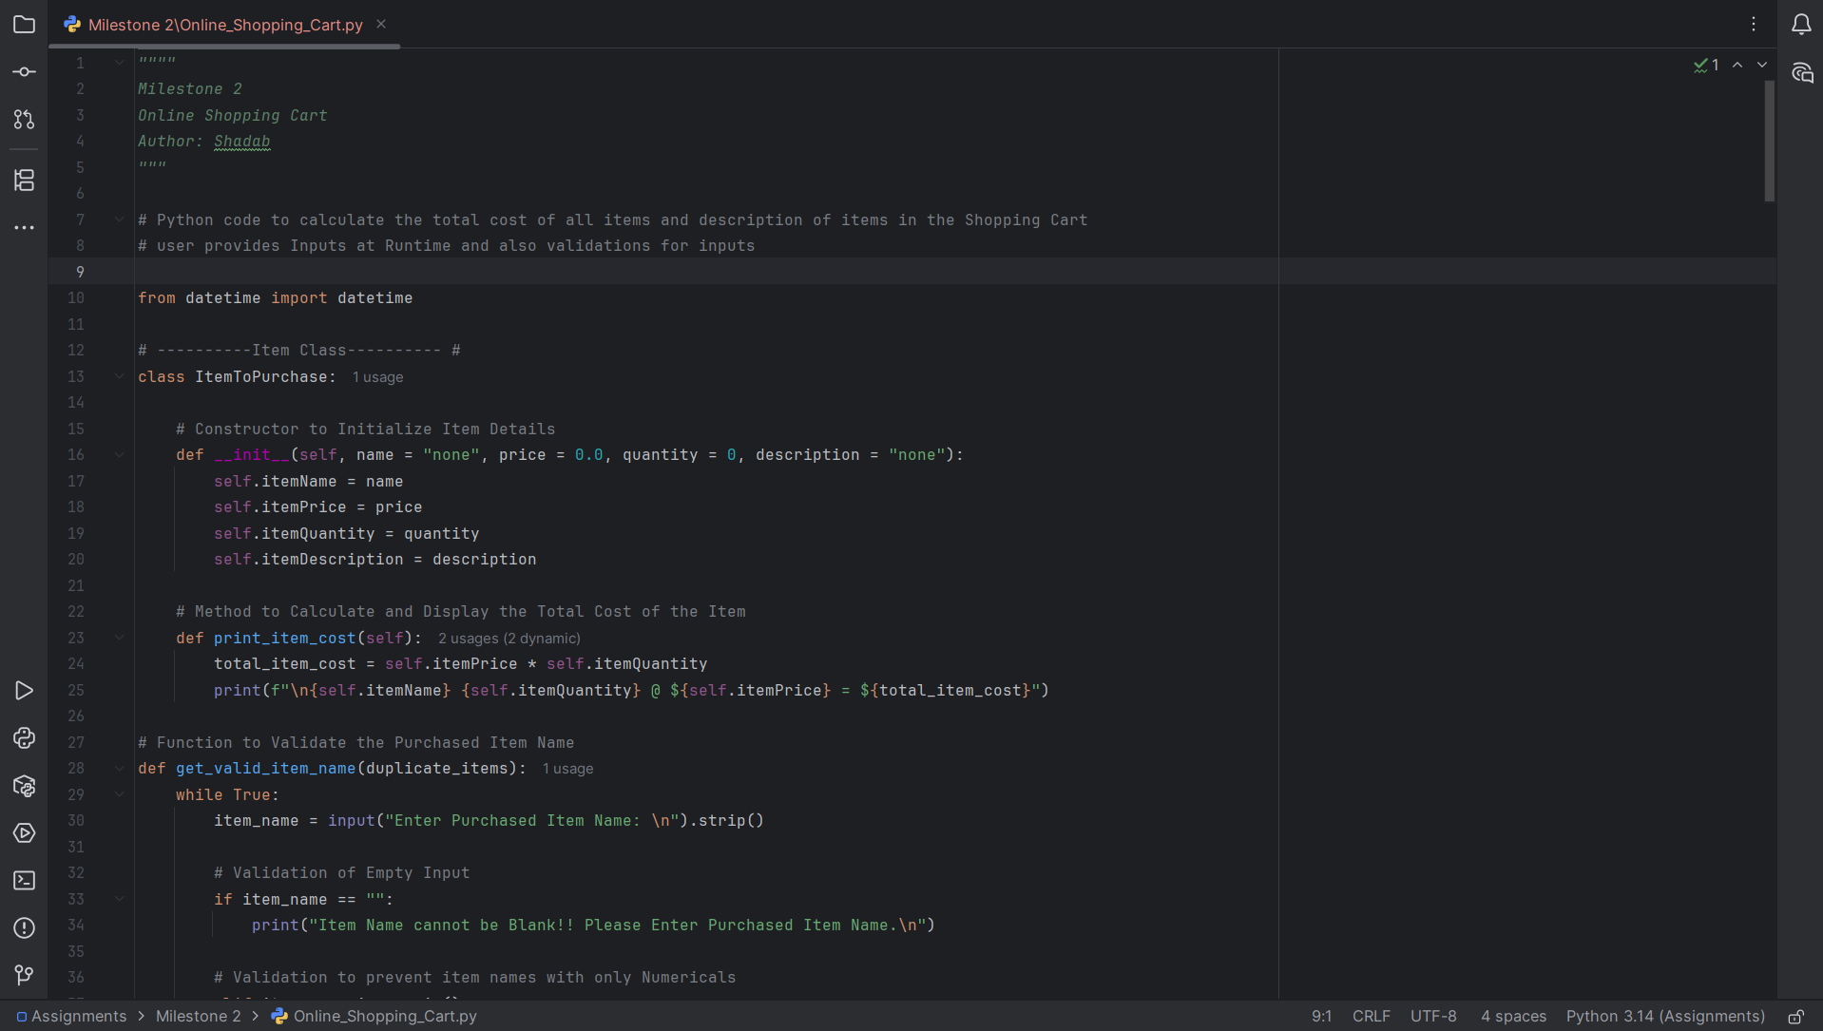

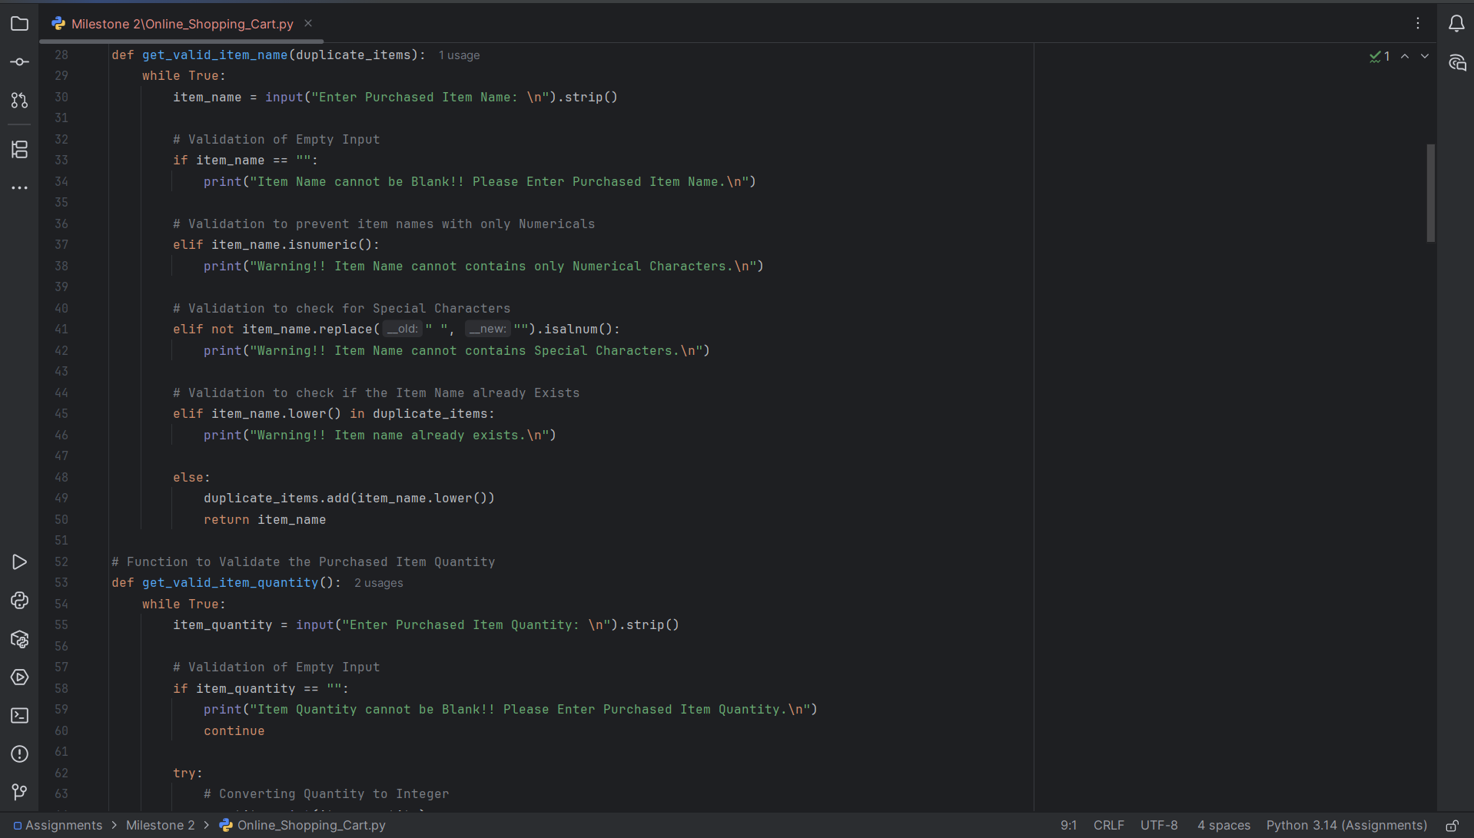

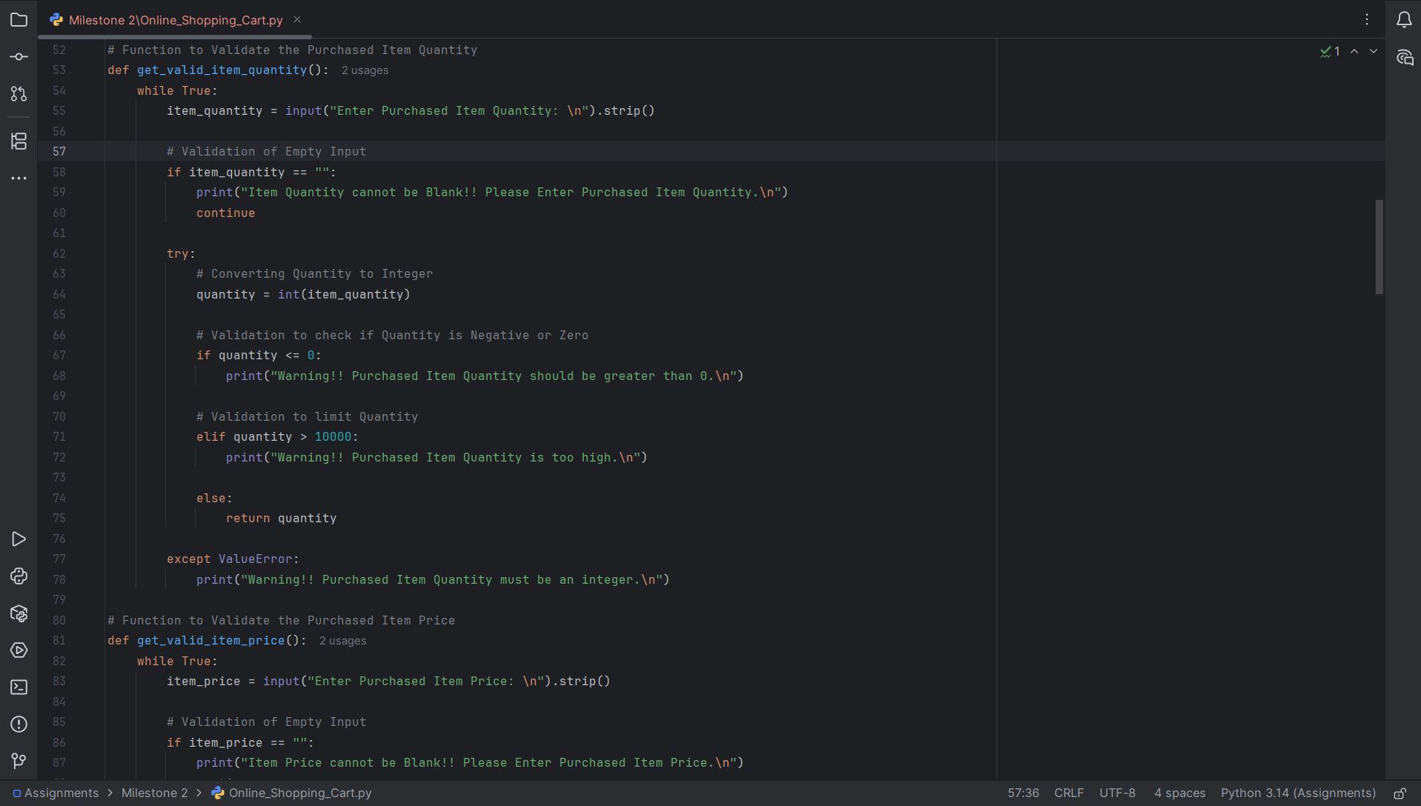

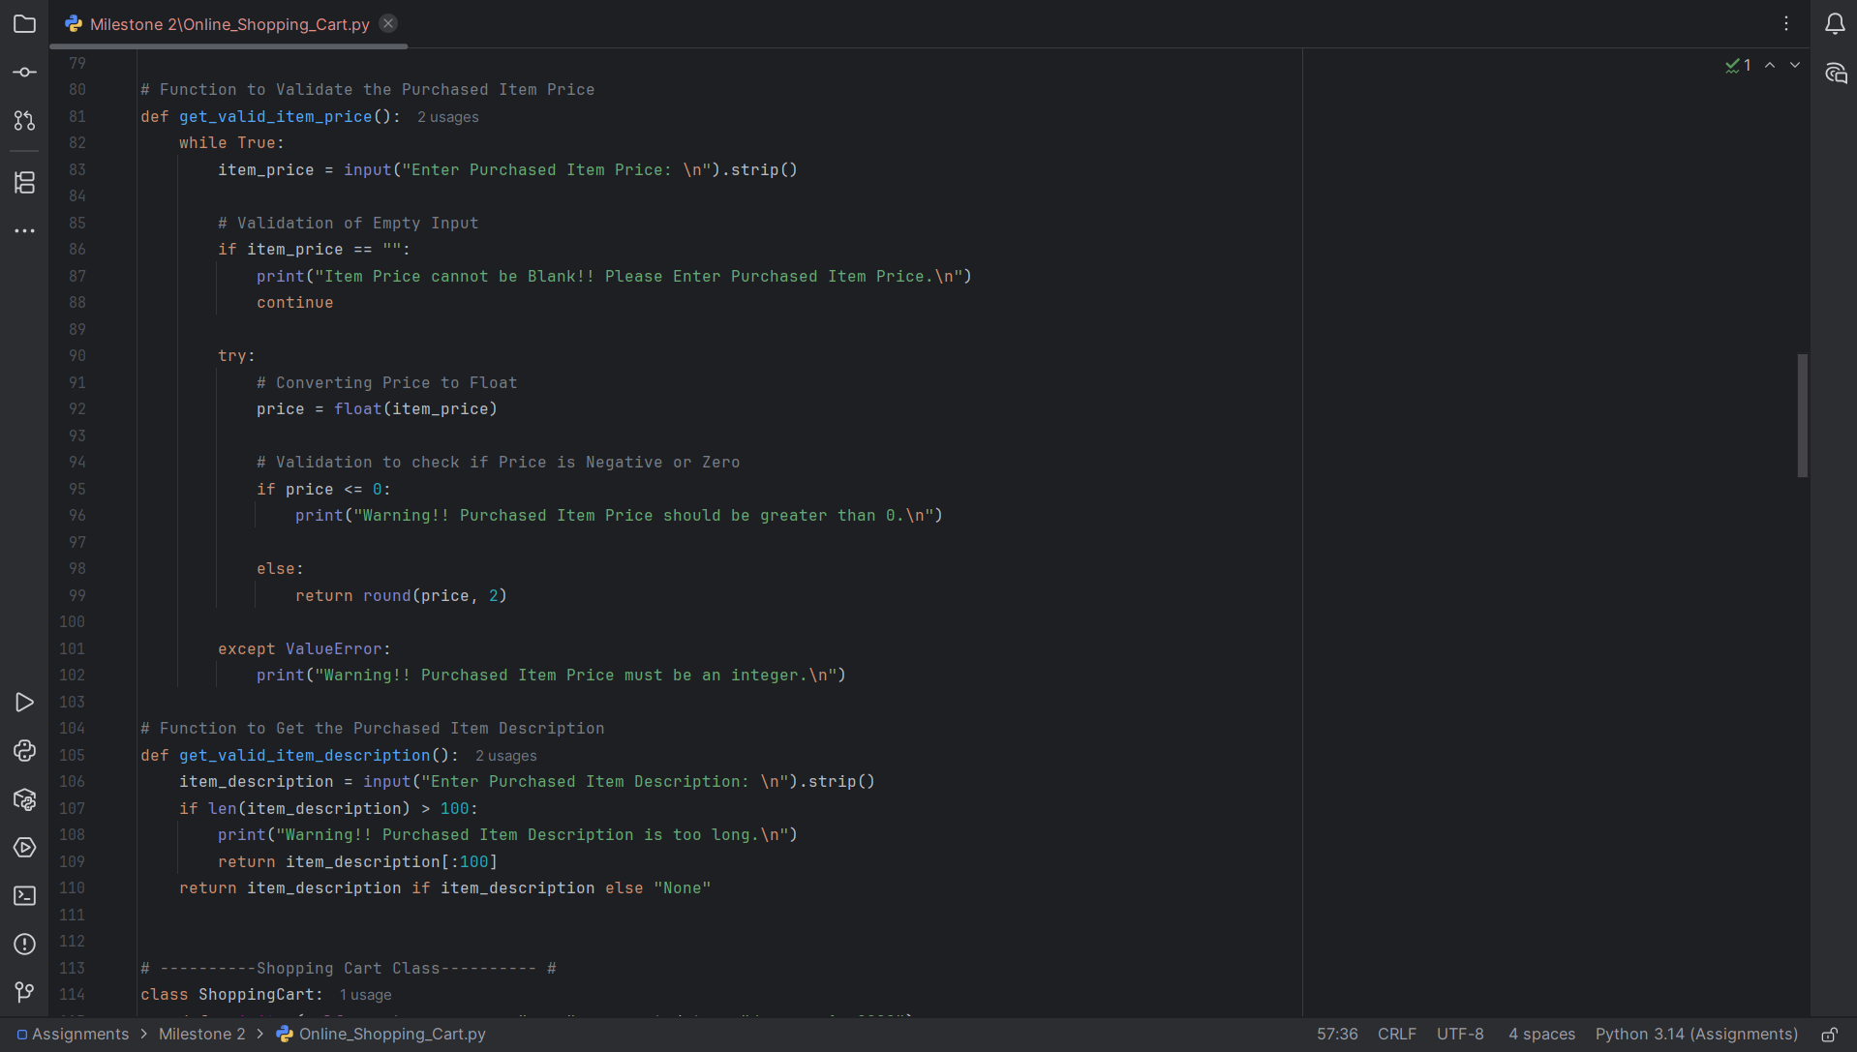

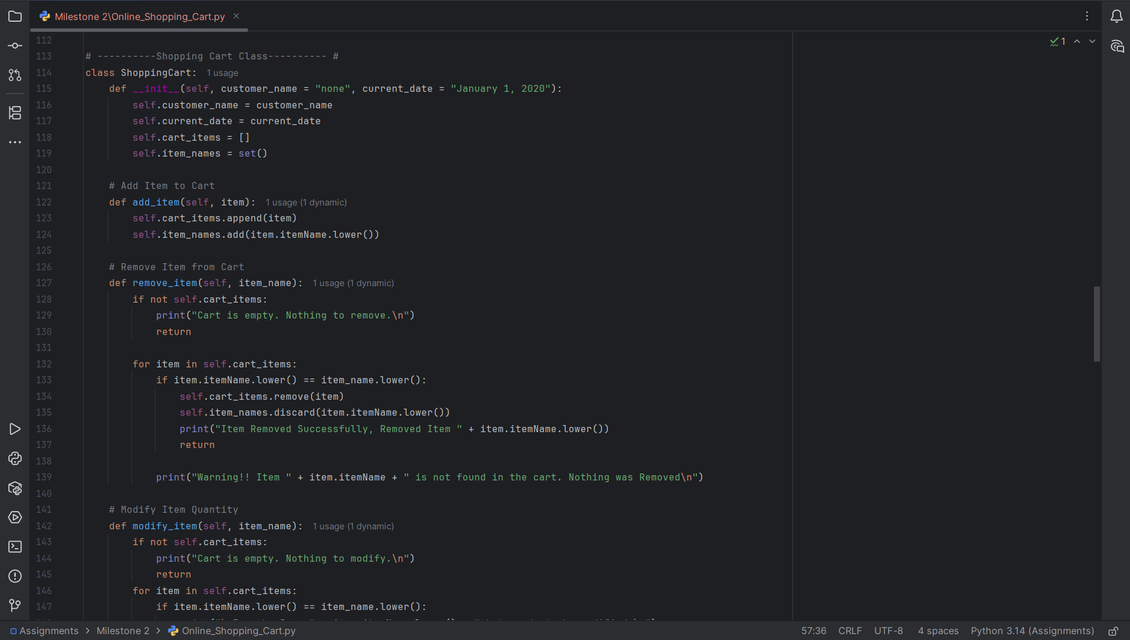

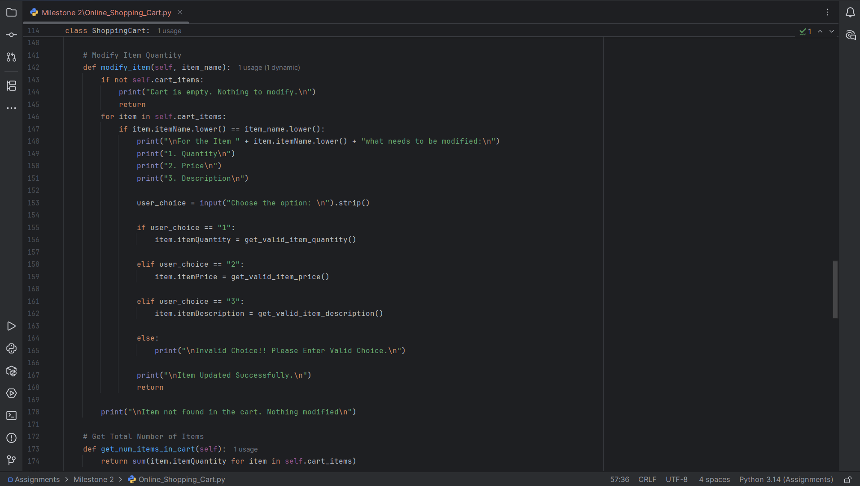

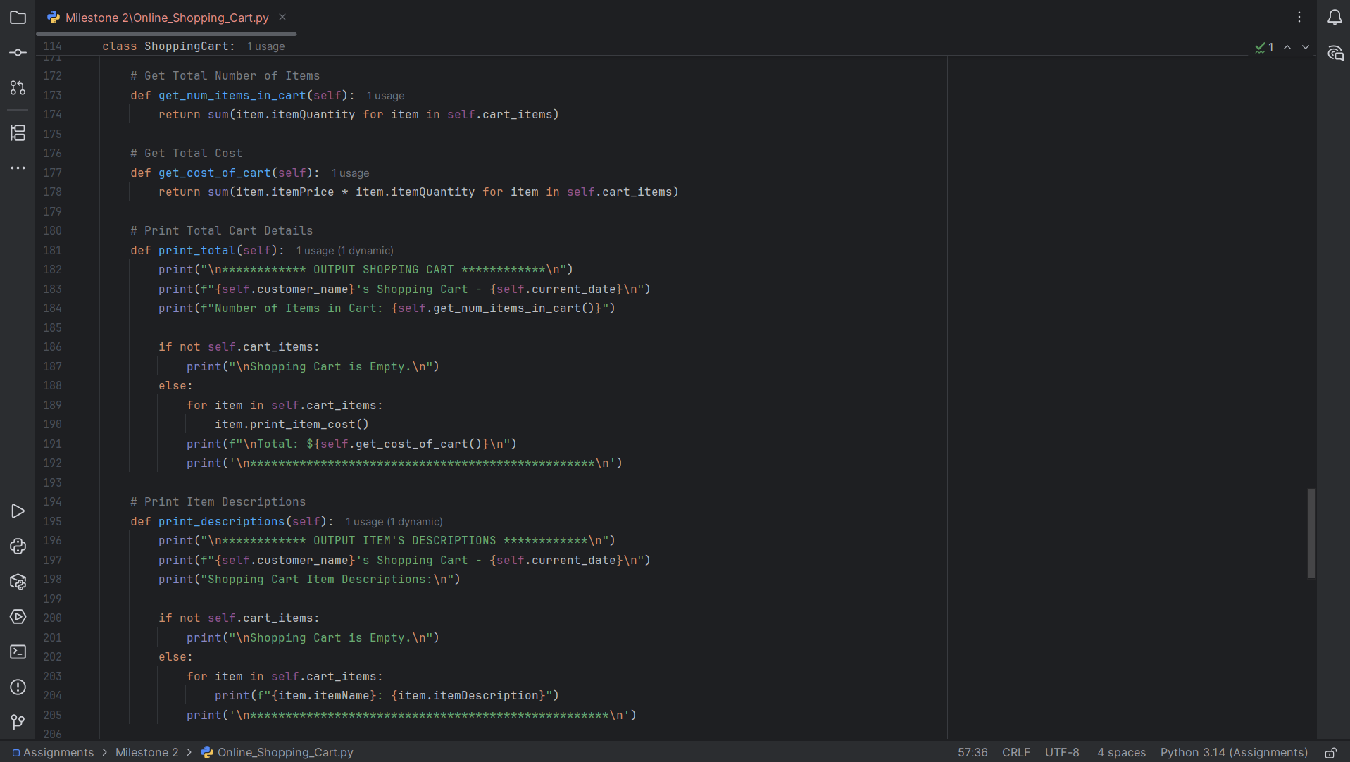

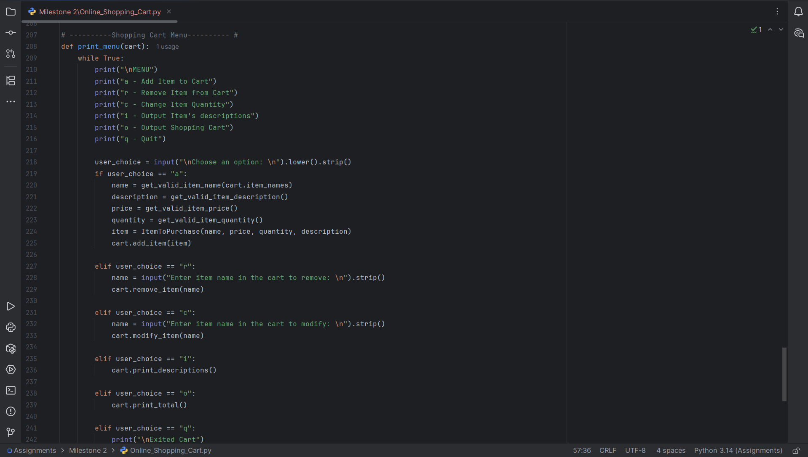

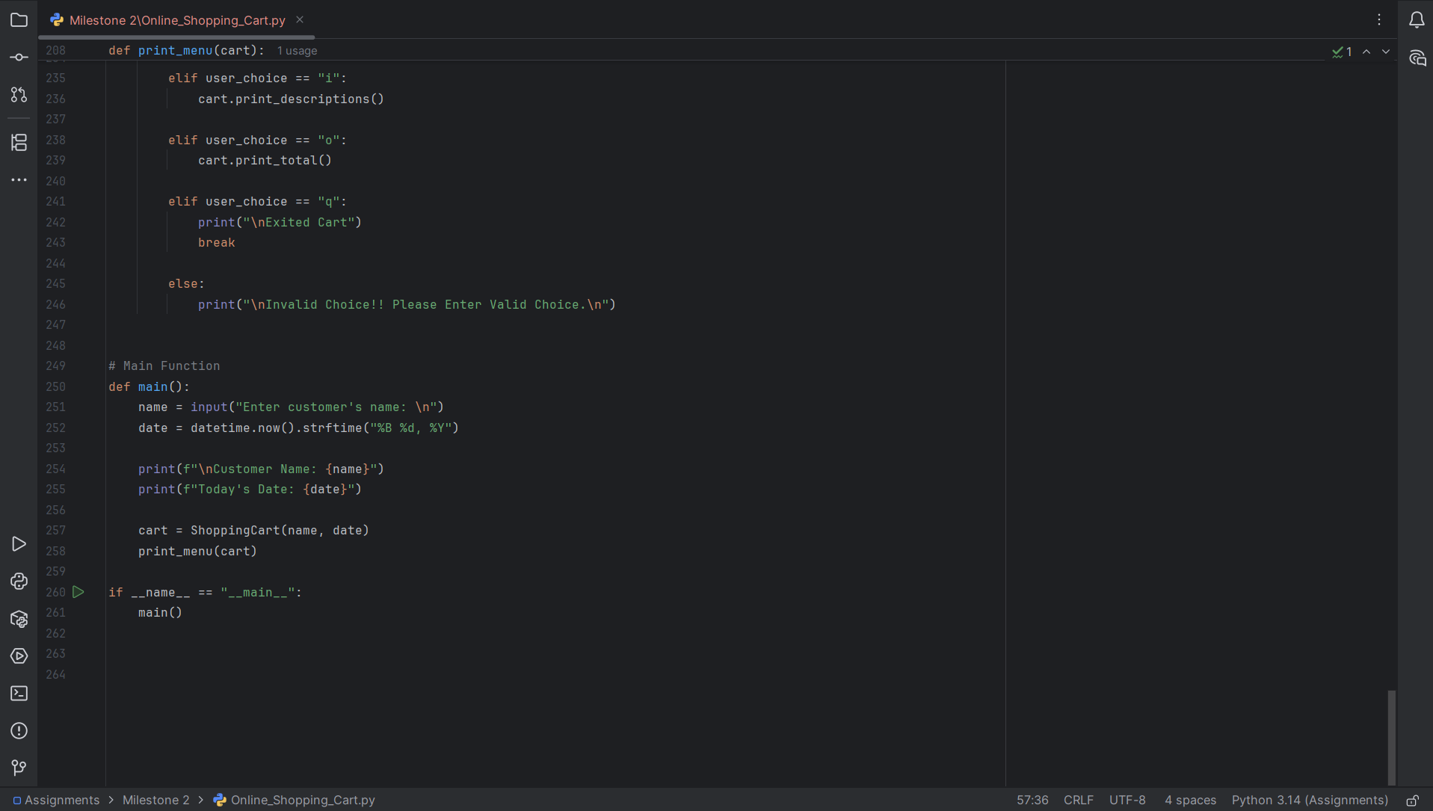

Program Execution Screenshots
Validation 1: Customer Name
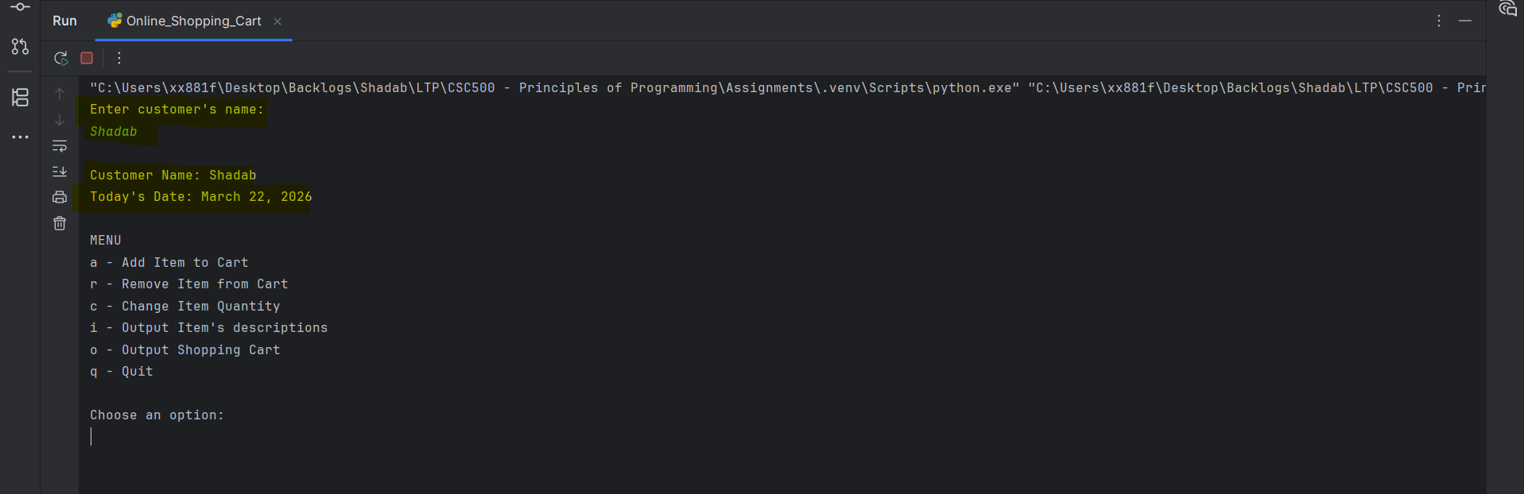

Validation 2: Invalid Choice from menu
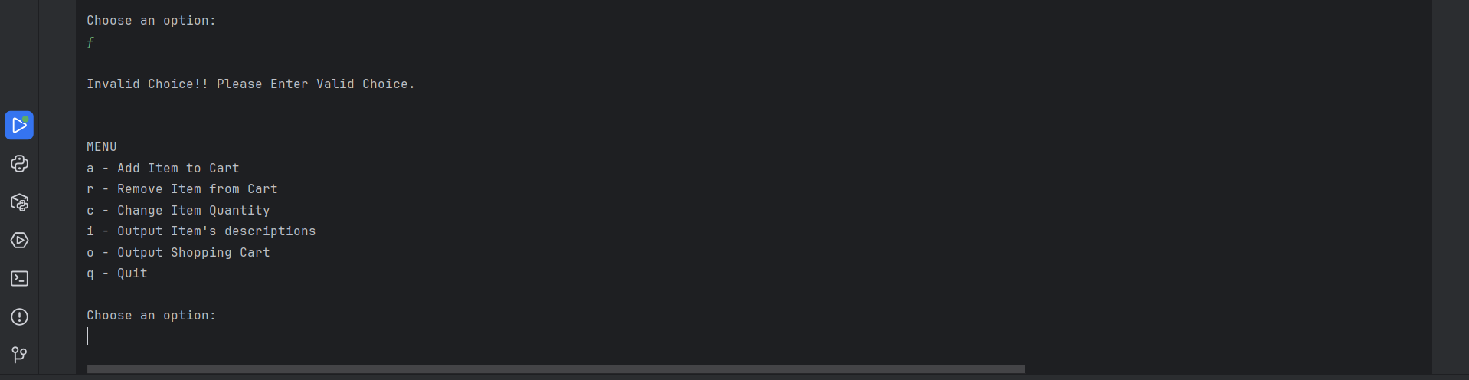

Validation 3: Add Item
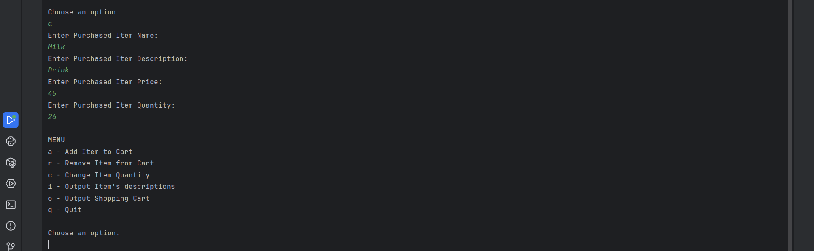

Validation 4: Modify Item
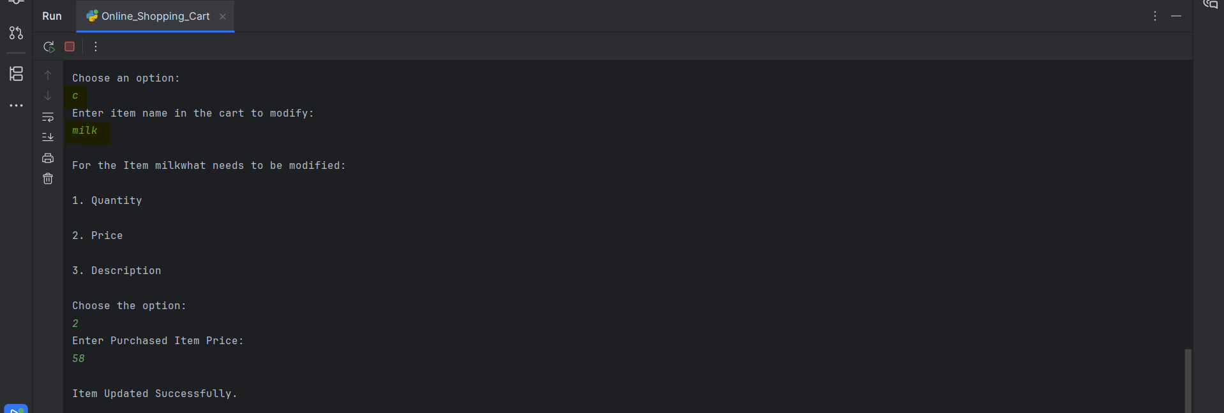

Validation 5: Remove Item
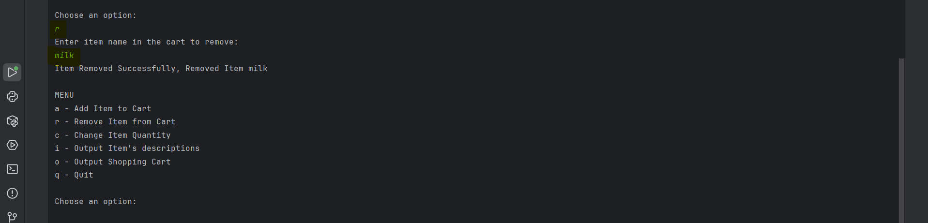

Final Result
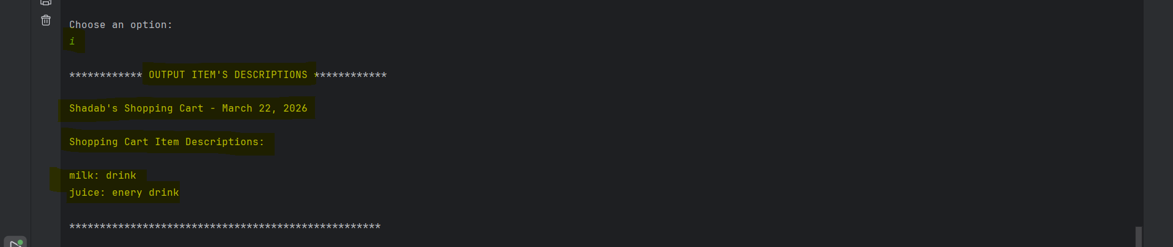

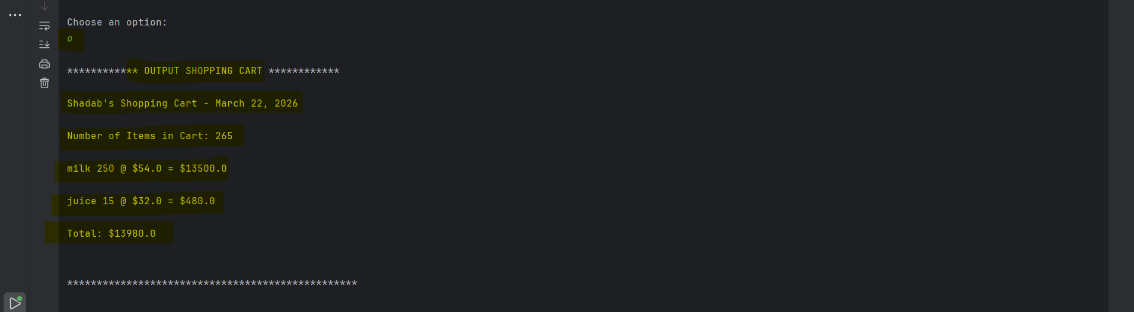

Git
